SET 5: WEBSITE ANALYTICS
Course: DSA0601 – Data Handling and Visualization using R
Aim
To analyze website traffic data using R programming and create visualizations and a Tableau dashboard for interactive exploration.
Dataset
Date | Page Views | Click-through Rate
2023-01-01 | 1500 | 2.3%
2023-01-02 | 1600 | 2.7%
2023-01-03 | 1400 | 2.0%
2023-01-04 | 1650 | 2.4%
2023-01-05 | 1800 | 2.6%
PROGRAM 1: LINE CHART
Aim: To create a line chart to visualize the trend in daily page views over time.
# Website Traffic Line Chart
date <- as.Date(c(
"2023-01-01",
"2023-01-02",
"2023-01-03",
"2023-01-04",
"2023-01-05"
))
page_views <- c(1500, 1600, 1400, 1650, 1800)
plot(
date,
page_views,
type = "o",
main = "Daily Page Views Trend",
xlab = "Date",
ylab = "Page Views",
pch = 19,
col = "blue"
)
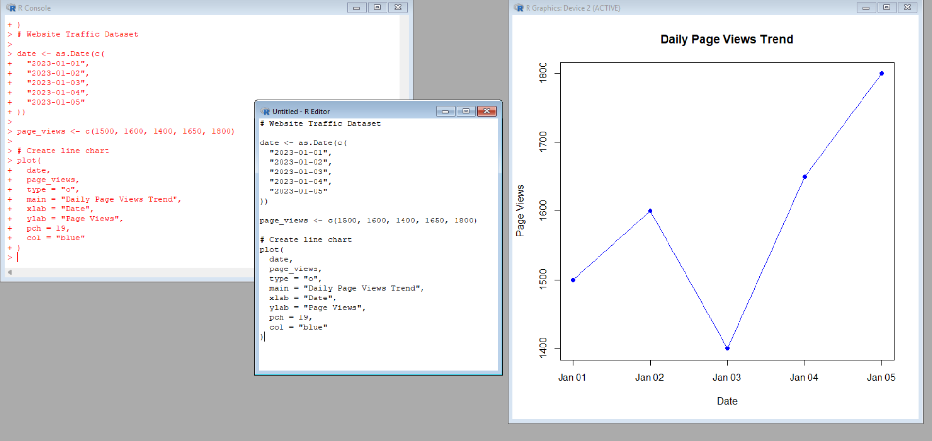
Explanation
plot() creates the graph. The date values are placed on the X-axis and page views on the Y-axis. type = "o" displays both points and connecting lines. main gives the title, while xlab and ylab label the axes.
Observation
Page views fluctuate during the five days. They decrease on 2023-01-03 and then increase, reaching the highest value of 1800 on 2023-01-05.
PROGRAM 2: BAR CHART – TOP N DAYS
The question asks for the top N days but does not specify the value of N. For this lab demonstration, N = 3 is used. The three days with the highest click-through rates are selected from the given dataset.
# Top 3 Days by Click-through Rate
date <- as.Date(c(
"2023-01-01",
"2023-01-02",
"2023-01-03",
"2023-01-04",
"2023-01-05"
))
click_through_rate <- c(2.3, 2.7, 2.0, 2.4, 2.6)
# Select top 3 days
top_n <- 3
order_index <- order(click_through_rate, decreasing = TRUE)[1:top_n]
top_dates <- date[order_index]
top_ctr <- click_through_rate[order_index]
bars <- barplot(
top_ctr,
names.arg = format(top_dates, "%Y-%m-%d"),
main = "Top 3 Days by Click-through Rate",
xlab = "Date",
ylab = "Click-through Rate (%)",
col = c("skyblue", "lightgreen", "orange")
)
text(
bars,
top_ctr,
labels = paste0(top_ctr, "%"),
pos = 3
)
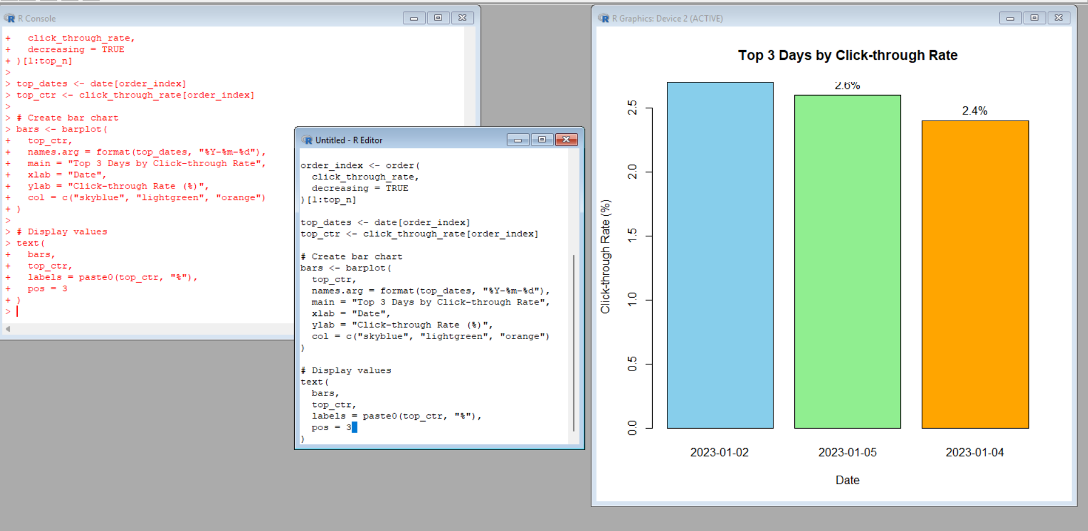
Explanation
order() sorts the click-through rates in descending order. The first three values are selected because N = 3. barplot() creates the bar chart and text() displays the percentage values.
Observation
The top three days by click-through rate are 2023-01-02 (2.7%), 2023-01-05 (2.6%), and 2023-01-04 (2.4%).
PROGRAM 3: STACKED AREA CHART
The original dataset contains only Date, Page Views, and Click-through Rate. It does not contain separate counts for likes, shares, and comments. Therefore, the interaction values below are illustrative values added only to demonstrate the required stacked area chart. They are not part of the original dataset.
# Illustrative User Interaction Data
# Likes, Shares and Comments are added only for demonstration
date <- as.Date(c(
"2023-01-01",
"2023-01-02",
"2023-01-03",
"2023-01-04",
"2023-01-05"
))
likes <- c(120, 135, 110, 145, 160)
shares <- c(50, 60, 45, 65, 75)
comments <- c(30, 35, 25, 40, 45)
# Create interaction matrix
interaction_data <- rbind(
Likes = likes,
Shares = shares,
Comments = comments
)
# Create stacked area chart
matplot(
date,
t(interaction_data),
type = "l",
lty = 1,
lwd = 2,
col = c("blue", "green", "red"),
xlab = "Date",
ylab = "Number of Interactions",
main = "User Interactions Over Time"
)
# Add filled areas
polygon(
c(date, rev(date)),
c(likes, rep(0, length(likes))),
col = rgb(0, 0, 1, 0.3),
border = NA
)
legend(
"topleft",
legend = c("Likes", "Shares", "Comments"),
col = c("blue", "green", "red"),
lty = 1,
lwd = 2
)
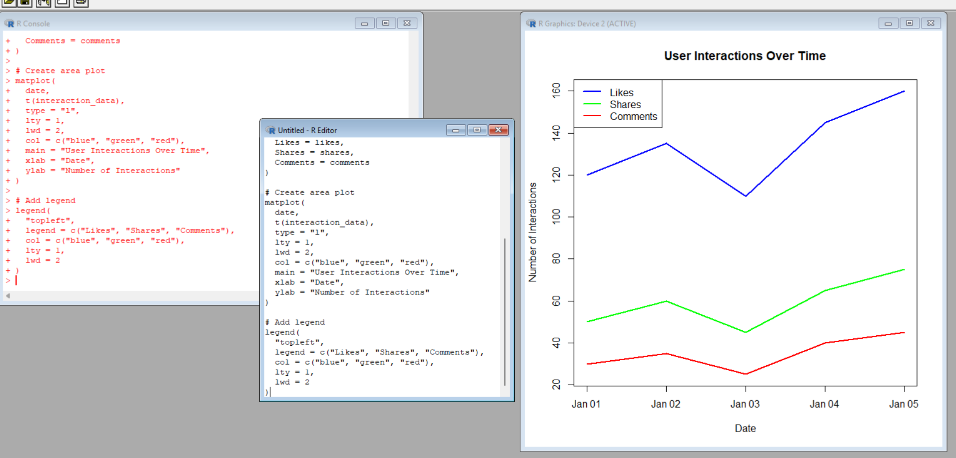
Explanation
The illustrative likes, shares, and comments are arranged as separate interaction series. The chart displays their values across the five dates. The legend identifies the three interaction types.
Note: The code above demonstrates the interaction data requested by the question. Since the original source dataset does not provide these values, they must be treated as illustrative.
Observation
The illustrative data shows likes as the largest interaction type, followed by shares and comments. Overall interaction values increase toward 2023-01-05 in the illustrative dataset.
PROGRAM 4: TABLEAU DASHBOARD
Aim: To create a Tableau dashboard containing the line chart and bar chart for interactive exploration of website traffic data.
Step 1: Create Excel Dataset
Create an Excel file named Website_Traffic.xlsx containing Date, Page Views, Click-through Rate, and the illustrative interaction fields Likes, Shares, and Comments if the interaction chart is also required in Tableau.
Date | Page Views | CTR | Likes* | Shares* | Comments*
2023-01-01 | 1500 | 2.3% | 120 | 50 | 30
2023-01-02 | 1600 | 2.7% | 135 | 60 | 35
2023-01-03 | 1400 | 2.0% | 110 | 45 | 25
2023-01-04 | 1650 | 2.4% | 145 | 65 | 40
2023-01-05 | 1800 | 2.6% | 160 | 75 | 45
* Likes, Shares, and Comments are illustrative values because they are not included in the original dataset.
Step 2: Open Tableau
- Open Tableau Desktop or Tableau Public.
- Select Connect → Microsoft Excel.
- Choose Website_Traffic.xlsx.
- Select the worksheet and verify that the fields are correctly recognized.
Worksheet 1: Line Chart
- Create a new worksheet named Daily Page Views Trend.
- Drag Date → Columns.
- Drag Page Views → Rows.
- Select Line from the Marks card.
- Set the title to Daily Page Views Trend.
- Ensure Date is treated as a continuous date if required.
Worksheet 2: Top N Bar Chart
- Create a new worksheet named Top N Click-through Rate Days.
- Drag Date → Columns.
- Drag Click-through Rate → Rows.
- Select Bar from the Marks card.
- Sort the bars in descending order of Click-through Rate.
- Use a Top N filter if desired; for this lab, N = 3.
- Set the title to Top 3 Days by Click-through Rate.
- Turn on Show Mark Labels to display the percentages.
Step 3: Create Tableau Dashboard
- Click New Dashboard.
- Rename it Website Traffic Analytics Dashboard.
- Drag Daily Page Views Trend into the dashboard.
- Drag Top N Click-through Rate Days into the dashboard.
- Arrange and resize both charts for clear viewing.
- Add the dashboard title Website Traffic Analytics Dashboard.
Step 4: Add Interactivity
- Add Date as a filter if required and choose Show Filter.
- Use Dashboard → Actions → Filter to allow selections in one chart to filter another.
- The dashboard can be used to explore page-view trends and the highest click-through-rate days interactively.
7. Procedure
- Open R/RStudio.
- Enter the given website traffic dataset.
- Execute the line chart program.
- Execute the top N bar chart program using N = 3.
- Use the clearly labeled illustrative interaction data for the stacked area chart.
- Create the Excel file for Tableau.
- Import the Excel file into Tableau.
- Create the line chart worksheet.
- Create the top N bar chart worksheet.
- Combine both worksheets into a dashboard.
- Add filters and dashboard interactions.
8. Result
The Website Traffic dataset was successfully analyzed using R. A line chart was created to visualize daily page-view trends, a bar chart was created to display the top three days by click-through rate, and a stacked area chart was demonstrated using clearly labeled illustrative user-interaction data. A Tableau dashboard containing the line chart and bar chart was also designed.

